# CS 255 System Design Document Template

## UML Diagrams

### UML Use Case Diagram

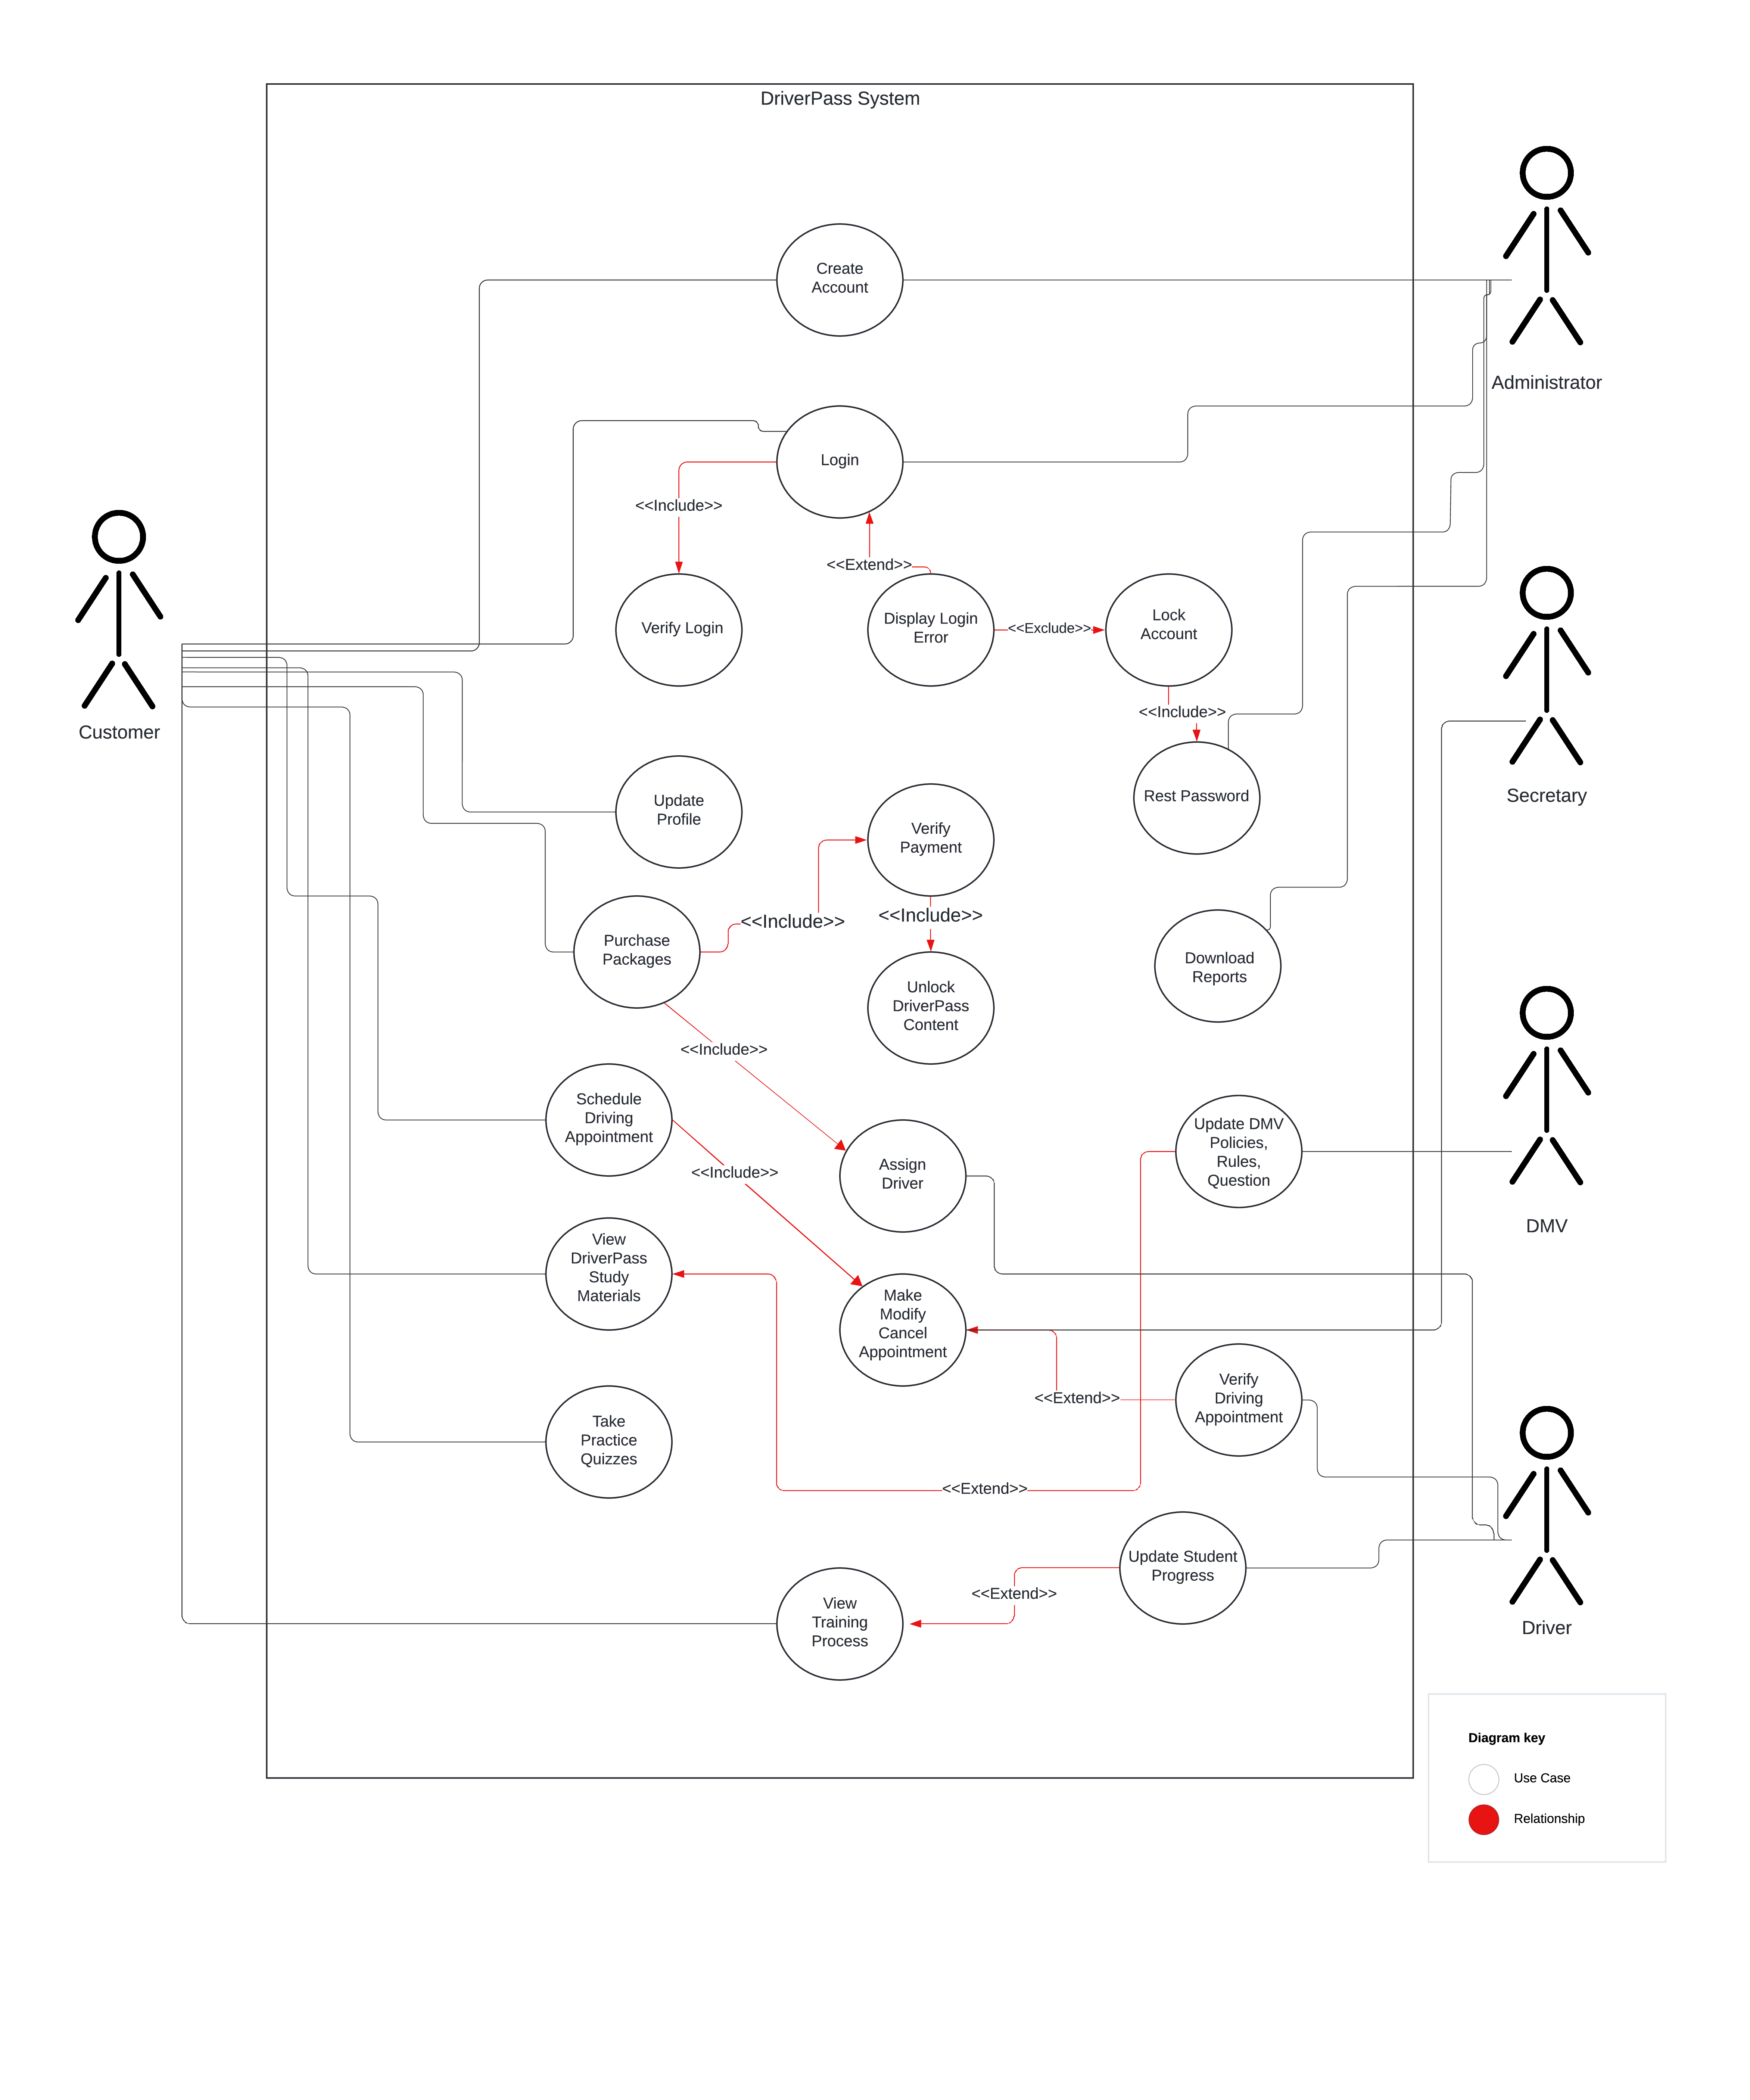

### UML Activity Diagrams

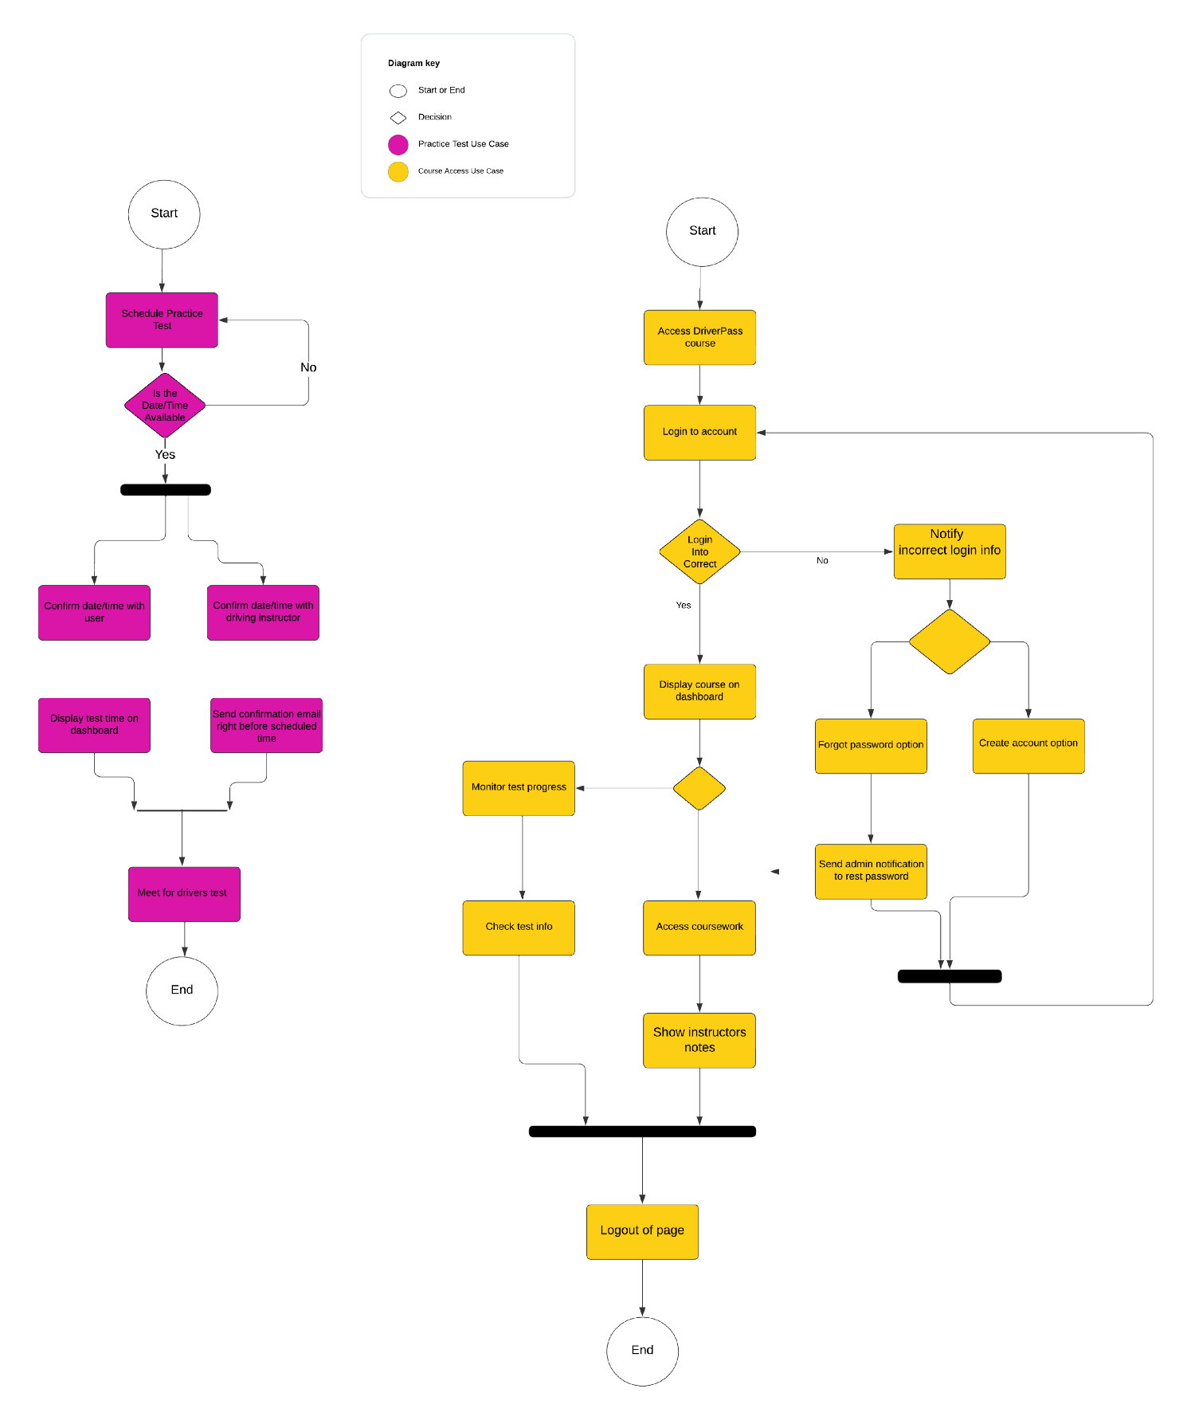

### UML Sequence Diagram

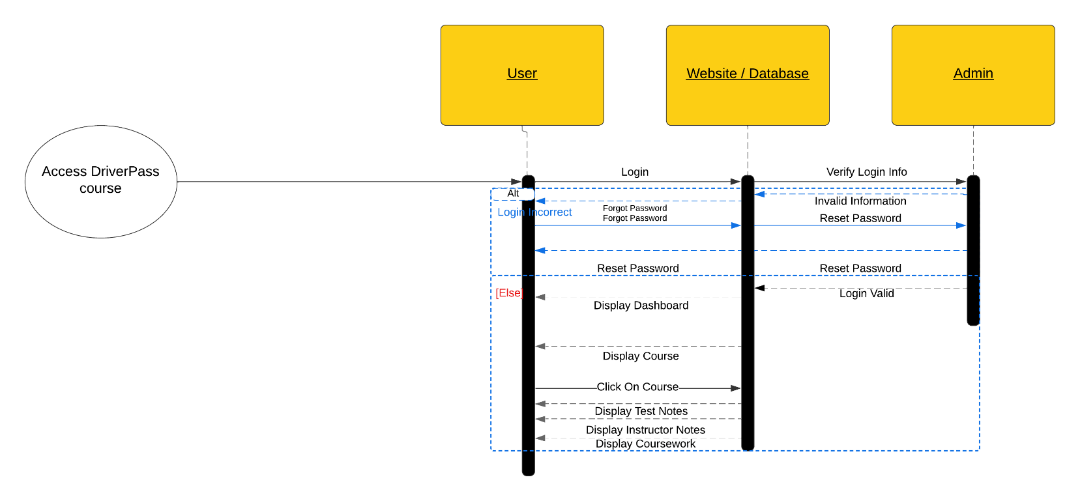

### UML Class Diagram

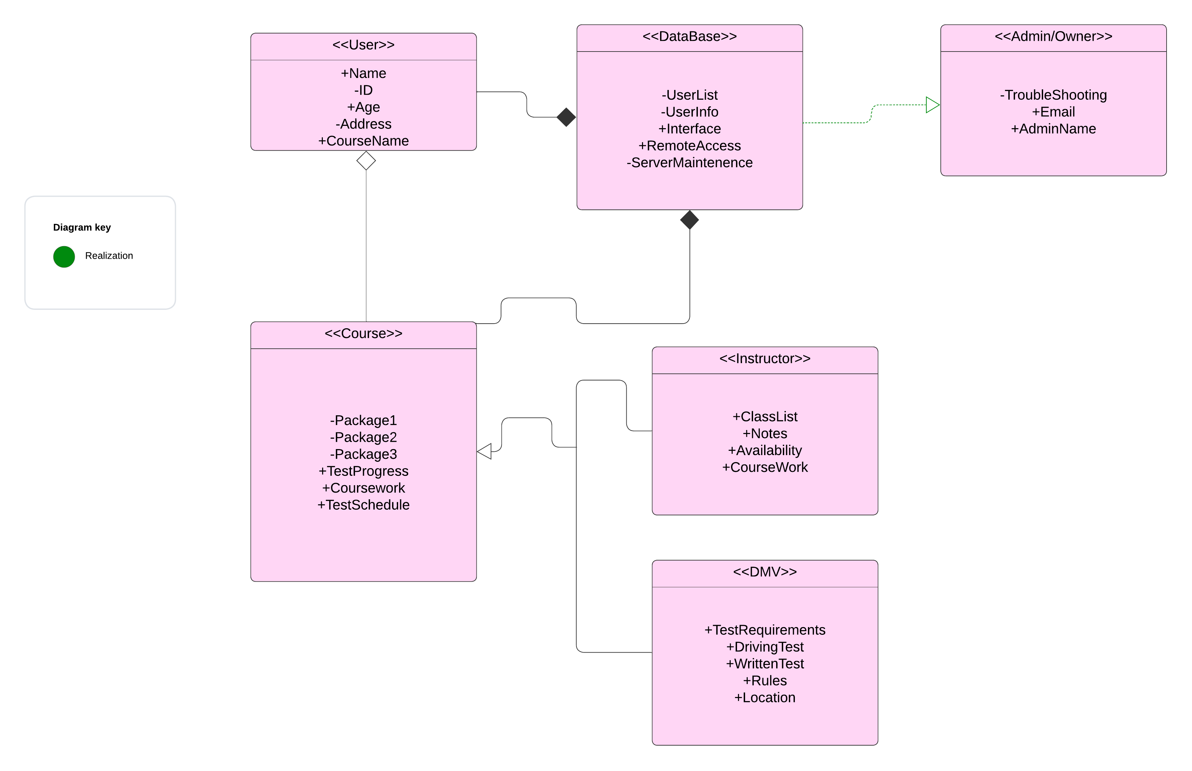

## Technical Requirements

➔Cloud Database

➔Third Party secure login system

➔OS availability

◆MacOS

◆Windows

◆Linux

◆Mobile

➔Secure payment system

➔3 Packages

➔Admin access

➔Customizable Interface

◆Test progress

◆instructor info

◆coursework

◆packages

◆scheduling

◆Student photo

◆Instructor photo

➔Package modification

➔Hire instructors

➔Access to DMV test requirements

➔Internet Access

➔Cloud Database

➔Third Party secure login system

➔OS availability

◆MacOS

◆Windows

◆Linux

◆Mobile

➔Secure payment system

➔3 Packages

➔Admin access

➔Customizable Interface

◆Test progress

◆instructor info

◆coursework

◆packages

◆scheduling

◆Student photo

◆Instructor photo

➔Package modification

➔Hire instructors

➔Access to DMV test requirements

➔Internet Access

➔Cloud Database

➔Third Party Secure Login system

➔OS availability

◆MacOS

◆Windows

◆Linux

◆Mobile

➔Secure Payment System

➔3 Packages

➔Admin Access

➔Customizable Interface

◆Test Progress

◆Instructor Info

◆Coursework

◆Packages

◆Scheduling

◆Student Photo

◆Instructor Photo

➔Package Modification

➔Hire Instructors

➔Access to DMV Test Requirements

➔Internet Access